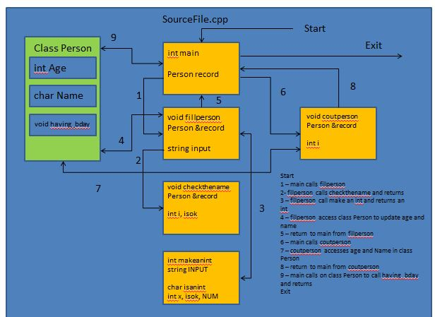

1

15

14

13

12

111

10

9

8

7

6

2

4

3

5

1

void integerCheck(int &age);

Main{

person person1;

person1.results(person1);

person1.having_birthday(person1);

}

void having_birthday(person & person1);

int getAge();

char *getName(){

char name1 [20];}

void results(person &person1);

**public:**

Class person

char name[20];

int age;

**private:**

Problem4.cpp